#### Polyclonal Antibody to Lipase, Hepatic (LIPC)

PA13063 100ul

# [ PROPERTIES ]

**Source: Poly**clonal antibody preparation

**Host: Rabbit**

**Purification**: Antigen-specific affinity chromatography followed by Protein A affinity

chromatography.

**Traits**: Liquid

Concentration: 0.5mg/ml

Ig Isotype:IgG

**UOM**: 100µl

**Cross Reactivity**: Human, Mouse, Rat

**Applications**: WB; ICC; IHC-P; IHC-F; ELISA.

**[ IMMUNOGEN ]**

Immunogen: Recombinant protein of human LIPC (Ser347~Pro478) .

**[ APPLICATIONS ]**

**Western blotting:** 1-5µg/mL**;**

**Immunohistochemistry:** 5-20µg/mL**;**

**Immunocytochemistry:** 5-20µg/mL**;**

Optimal working dilutions must be determined by end user.

# [ FORMULATION ]

**Form & Buffer:** Supplied as solution form in 0.01M PBS, pH7.4, containing 0.05% Proclin-300, 50% glycerol.

# [ STORAGE AND STABILITY ]

**Storage:** Avoid repeated freeze/thaw cycles.

Store at 4ºC for frequent use.

Aliquot and store at -20ºC for 12 months.

**Stability Test:** The thermal stability is described by the loss rate. The loss rate was determined by accelerated thermal degradation test, that is, incubate the protein at 37°C for 48h, and no obvious degradation and precipitation were observed. The loss rate is less than 5% within the expiration date under appropriate storage condition.

# [ IDENTIFICATION ]

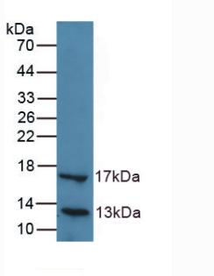

**Western Blot; Sample:**

**Sample: Recombinant LIPC, Human.**

# [ IMPORTANT NOTE ]

The kit is designed for research use only, we will not be responsible for any issue if the kit was used in clinical diagnostic or any other procedures.